Introduction to measurement conversions …….

Weights
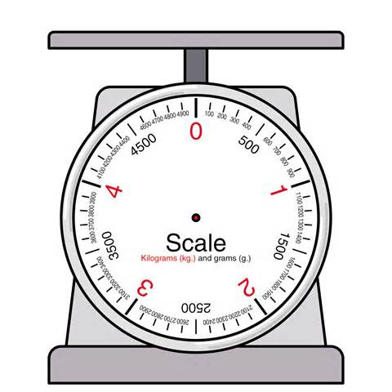
1000g = 1 kg 5kg = __________g

2000g = ________kg 4kg = __________g

3000g = ________kg 2kg = __________g

Lengths
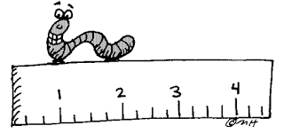
100cm = 1M 8M = __________cm

700cm = ________M 3M = __________cm

200cm = ________M 6M = __________cm

Liquids
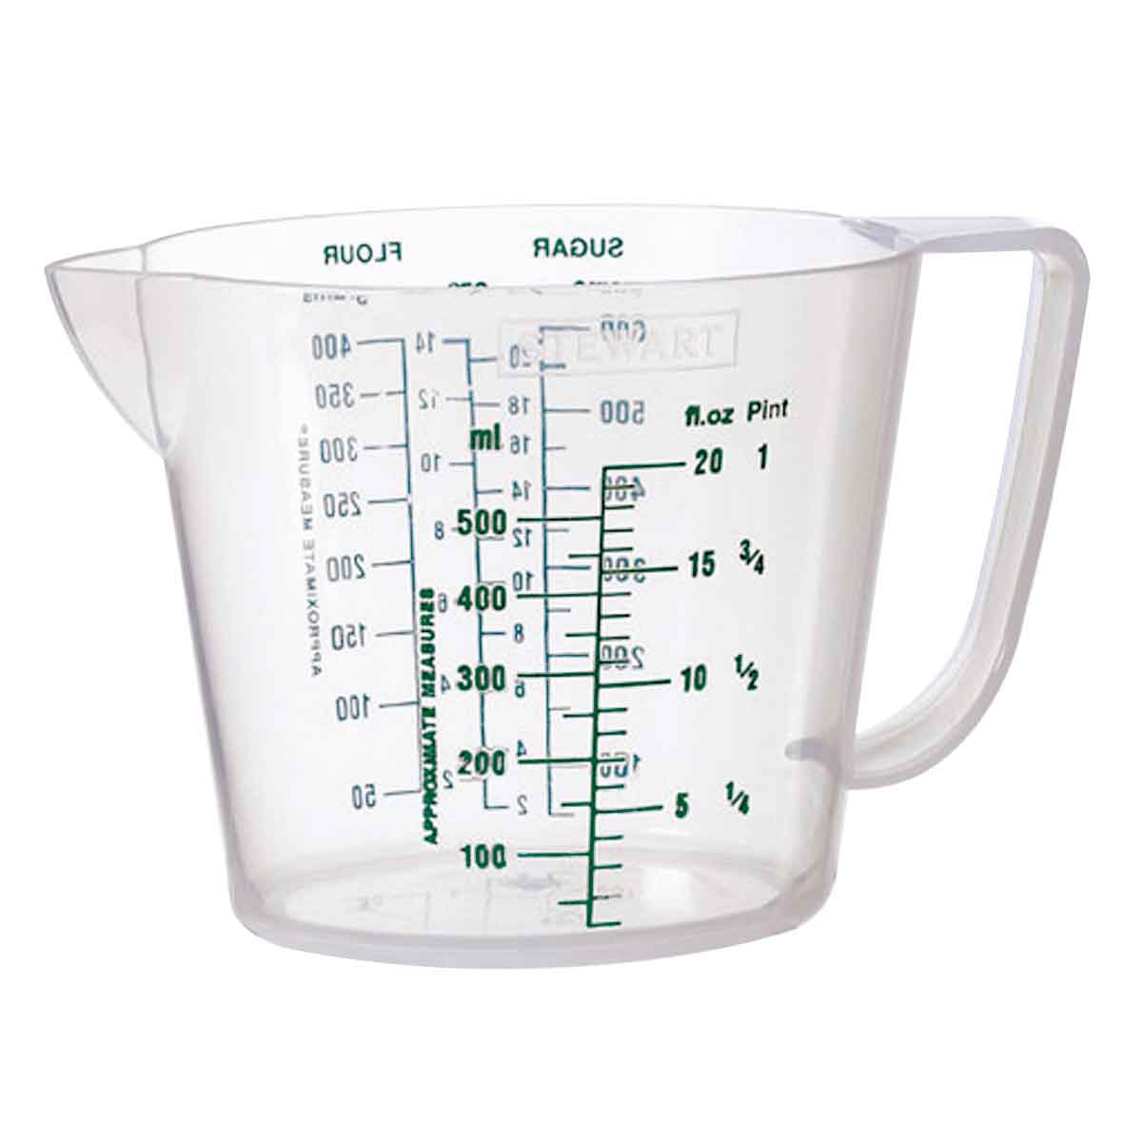
1000ml = 1 l 5 l = __________ml

2000ml = ________l 4 l = __________ml

3000ml = ________l ½ l = __________ml

ml, l, cm, M, g, kg
Using the above, which would you use to measure small things: _________________
Using the above, which would you use to measure big things: ___________________

How many centimetres in a metre? _________

How many millilitres in a litre? _________

How many grams in a kilogram? _________

What unit of measurement would you use to weigh yourself? _____________

What unit of measurement would you use to find the length of a pencil? __________

What unit of measurement would you use to measure the amount of water in a bath? _____________

What unit of measurement would you use to find the length of the room? _________

What unit of measurement would you use to weigh an apple? _____________

What unit of measurement would you use to measure the amount of milk in a cup? _____________

